

WEBINAR
Trauma-Sensitive Schools: Responding to COVID-19

CEUS AND CREDITS FOR K-12 TEACHERS

We are glad you can join the Center for Partnership Studies for the Thursday, March 19, 2020 webinar Trauma-Sensitive Schools: Responding to COVID-19 —a timely online dialogue with Dr. Mary Crnobori, BCBA, Khayree Bey, BBSc, M.Ed. and Dr. Riane Eisler.

CEUs, WA State clock hours, OR State PDUs and continuing education quarter credits are available for attending the webinar through the World We Want self-design online course, a program of The Heritage Institute. Quarter credits are accredited through Antioch University Seattle.

The World We Want Online Course
Teachers seeking CEUs or credits can register for the 10 hour (1 credit) WWW class and work at their own pace, completing within 6 months. (You are welcome to complete sooner, within one or two weeks). Although the webinar is 90 minutes, we ask that teachers seeking CEUs or credit complete all 10 hours of the World We Want class. It’s easy—read more:

After You Regsiter
When you have received your log-on instructions from The Heritage Institute and accessed your online learning space, you will follow the syllabus and introduce yourself (Assignment 1), then post a Learning Journal in the online course in which you will record 10 hours of activities (Assignment 2). These can include: your attendance at the webinar, reflection on your learning, reviewing and implementing the CPS follow-up resources, and any other associated activities*.

*Optional: Additionallly, the WWW course allows teachers to include in their 10 hours any activity that relates to one or more of the four action areas: Social Justice, Community Service, Inner Well-Being, and Ecoliteracy. These could include your own yoga or meditation classes, designing curriculum that connects trauma-sensitive school practices to local social justice issues, working in the school garden, watching environmental documentaries, creating local resources as a response to COVID-19, and a wealth of other activities. See: https://sites.google.com/site/annambergdesign/online-courses

Your instructor, Ann Amberg, MCs, will respond to you online in the course space and is available to you personally for guidance, resources, and mentoring. The syllabus is available on the Heritage Institute course page.

If you are seeking more hours or credits, you are welcome to regsiter for The World We Want 2, 3, 4, or 5 credit class.

Cost for CEUs/clock hours: $95.
Cost for 400/500 level credit: $125.

REGISTER FOR THE 10 HOUR WORLD WE WANT COURSE

Questions? Contact Ann at annamberg.cps@gmail.com

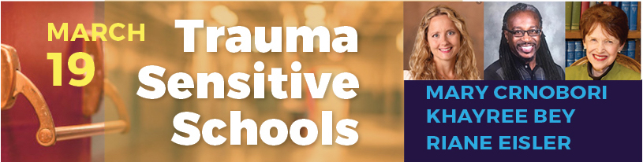

Webinar Description
https://centerforpartnership.org/news-events/trauma-sensitive-schools/

In response to the Coronavirus pandemic, many schools are closing for weeks or longer and we know that students, parents and communities are in need of informed and inspiring support. Given the urgency of the real issues at hand, our webinar this Thursday will focus on how we can better care for our families and school communities in the coming weeks.

Our webinar presenters are working directly with parents, teachers and schools to smooth this transition and offer effective trauma-informed responses. In this week’s webinar, they’ll address:

- Trauma-sensitive practices that can address the fear, confusion, and questions of our children, while offering compassion and kindness.
- How to prepare for traumatized children when they return to re-opened schools
- The mental-emotional challenges of life-threatening personal illness and illness of loved ones
- Issues related to equity for districts considering moving to distance learning
- How our family, community and societal immune system is boosted and sustained by partnership systems

